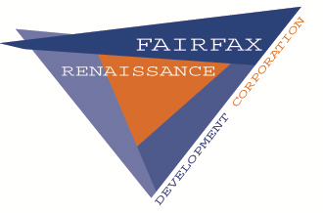
FAIRFAX RENAISSANCE DEVELOPMENT CORPORATION
Incorporated in the spring of 1992, Fairfax Renaissance Development Corporation (FRDC) is a nonprofit community development corporation whose mission is “strengthen neighborhoods in
Northeast Ohio through comprehensive community development." FRDC carries out community revitalization activity through the development of affordable and market rate housing, promotes economic development activity through commercial, retail and institutional initiatives, acts as a catalyst to spur community visioning through comprehensive master planning.

JOB DESCRIPTON
Position: AmeriCorps VISTA
Location: 8111 Quincy Avenue Suite 100 Cleveland, OH 44104
Member Duties:
Create digital organizational processes for resident outreach and implement community initiatives designed to digitize the neighborhood—such as the creation of educational classes on digital tools such as web design, social media, media software and the use of smart devices. Conduct resident outreach and identify community leaders that can form new neighborhood block clubs. Utilize resident leadership to identify how to connect individuals with access to affordable housing, healthy food access and utility assistance. Spearhead sustainability efforts on behalf of community partners to assist with the creation of community and resident gardens and urban farms.
Program Benefits:
Living Allowance, Training, Health Coverage, Education award upon successful completion of service, Choice of Education Award or End of Service Stipend, Childcare assistance if eligible, Relocation Allowance.
Service Terms:
Full Year of Service from 06/08/2020 - 06/07/2021. Permits attendance at school during off hours, Permits working at another job during off hours, Car recommended.
Service Areas:
Community and Economic Development.
Skills:
Recruitment, Public Speaking, Public Health, Community Organization, Leadership, Education, Communications, Computers/Technology, Fund raising/Grant Writing, Youth Development, Writing/Editing, General Skills, Teaching/Tutoring.

*Send Resume and Cover letter to Catondra Noye at cnoye@fairfaxdev.org

