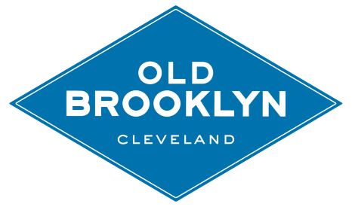
OLD BROOKLYN COMMUNITY DEVELOPMENT CORPORATION
Old Brooklyn Community Development Corporation (OBCDC) is a non-profit community development corporation located on the southwest side of Cleveland. OBCDC’s mission is to develop and revitalize the community by uniting and empowering residents, business leaders, and government around plans and initiatives and achieve social, economic, and civic improvement.
JOB DESCRIPTION
Position: Marketing & Advancement Intern
Location: 4274 Pearl Road, Cleveland, Ohio 44109
Status: Part-time 15-20 hours per week
Compensation: Negotiable
Duration: Fall Semester 2019 with opportunity for continuation to the Spring Semester 2020
Reports to: Director of Advancement
Responsibilities:
- Assist the Advancement Team with daily tasks
- Sample tasks include: managing and tracking performance of social media platforms, creating visual and written content for the OBCDC digital channels, provide support and assist with the organization’s publications:
  - Assist in the drafting, editing, and vision for digital communications including an e-newsletter, OldBrooklyn.com
  - Assist in the drafting and editing for the Old Brooklyn News, a quarterly magazine
  - Coordinate and assist in content creation for social media management in partnership with outside marketing agency
- Assist the Board’s fundraising committee with execution of the organization’s annual fundraiser
- Evaluate programs both current and potential for OBCDC to implement
- Introduce and provide the organization with strategies to increase brand awareness in the neighborhood and beyond
- Perform all other duties as assigned
Qualifications:
- Currently enrolled in Bachelor’s program or higher
- Strong written and verbal skills
- Ability to work independently and creatively
- Proficient with Microsoft Office, Squarespace, and other content creation platforms
- Knowledge of social media platforms and their function
- Ability to create and design content
- Strongly prefer photography and video skills

Please send resume and cover letter to devinc@oldbrooklyn.com. Position open until filled.

